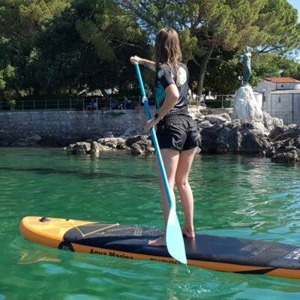

Lumbarda SUP Rental: Paddle Your Way Along Korčula’s Coast
Lumbarda is a wonderful destination for travelers who want to combine relaxation with outdoor adventure. Located on the island of Korčula, this charming coastal village is surrounded by the Adriatic Sea and offers beautiful scenery, calm bays, and inviting beaches. One of the most enjoyable ways to experience the coastline is through Lumbarda SUP Rental, giving visitors the opportunity to explore the water on a stand-up paddleboard.
Stand-up paddleboarding is accessible to many travelers and can be enjoyed as a relaxing activity or a gentle workout. From the surface of the sea, you can see the coastline from a different perspective while enjoying the freedom to paddle at your own speed.

What Makes SUP Popular in Lumbarda?
SUP combines several things that make an island holiday special: sunshine, exercise, sightseeing, and time on the water. You don't need to plan a complicated excursion to enjoy it. After receiving your equipment and basic instructions, you can head out when conditions are suitable and create your own route.
For beginners, calm water can make learning the basics more comfortable. Experienced paddlers may enjoy covering more distance and exploring different sections of the coastline.
Before setting off, always consider your experience level and the current sea and weather conditions.

Explore the Adriatic at Your Own Pace
One of the main benefits of Lumbarda SUP Rental is the freedom to decide how you spend your time on the water. You can paddle along the shoreline, pause for a swim, take photographs, or simply sit on the board and enjoy the scenery.
Unlike a fast boat excursion, SUP allows you to move slowly enough to appreciate the smaller details of the coastline. You may notice rocky formations, sea life beneath the clear water, or peaceful sections of shore that are easy to overlook from land.
Keep your route within your comfort level and avoid going farther offshore than you can safely manage.

Discover Beaches and Quiet Bays
Lumbarda's coastal environment provides plenty of opportunities for water-based exploration. A paddleboard can help you reach areas along the shoreline where you can take a break and enjoy the sea.
You might begin your session early in the morning when the water is calm, paddle along the coast, and stop at a suitable location for a swim. Later, you can return to the village for lunch or continue exploring on foot.
Always respect private property, protected areas, swimming zones, and any local restrictions that apply to the area you are visiting.

A Fun Activity for Couples and Friends
SUP can be a great shared experience. Couples can paddle side by side and enjoy a peaceful morning on the water, while friends can turn a rental session into an active part of their holiday.
If you're traveling with children, make sure the activity is appropriate for their age, swimming ability, and the conditions on the day. Younger or inexperienced participants should be closely supervised.
A rental provider can also help you choose equipment that matches your group and experience level.

Choosing the Right SUP Equipment
When comparing Lumbarda SUP Rental options, consider the equipment as well as the rental price. A stable, well-maintained board can make learning much easier, particularly for first-time paddlers.
Beginners often benefit from wider boards that provide greater stability. More experienced users may prefer a different design depending on whether they want speed, longer-distance paddling, or recreational use.
Ask what is included with the rental. Depending on the provider, the package may include a paddle, leash, safety equipment, and instructions for using the board.
Check the equipment before entering the water and report any existing damage to the rental provider.

Prepare for a Comfortable Paddle
Spending time on the water requires some basic preparation. Bring drinking water and use sunscreen, sunglasses, and other suitable sun protection. A waterproof bag can help protect your phone, keys, and other valuables.
Wear comfortable clothing suitable for getting wet. If you are planning a longer paddle, consider bringing an extra layer and enough water for the entire trip.
It's also sensible to check the forecast before leaving the shore. Wind can have a significant effect on paddleboarding, and conditions that appear comfortable from land may feel very different once you are on the water.

Safety Tips for Beginners
If you're new to SUP, start close to shore and practice basic movements before attempting a longer route. Learn how to stand comfortably, hold the paddle correctly, turn the board, and return safely to shore.
A leash can help keep the board nearby if you fall into the water, while appropriate safety equipment provides additional protection.
Don't underestimate the distance you can cover while paddling. It is often better to choose a shorter route and return with plenty of energy remaining than to venture too far.

Enjoy a Different Side of Lumbarda
A beach holiday doesn't have to mean spending the entire day sitting on the shore. Lumbarda SUP Rental gives travelers a chance to experience the Adriatic actively while still maintaining a relaxed holiday atmosphere.
You can paddle in the morning, explore the village afterward, enjoy a local meal, and return to the water later in the day if conditions remain suitable. The activity can easily fit into different types of travel plans.

Create Lasting Island Memories
Exploring Lumbarda by paddleboard offers a unique way to connect with the sea and surrounding landscape. Instead of simply looking at the Adriatic from the beach, you become part of the scenery, moving quietly across the water and discovering the coastline from a new viewpoint.
Whether you're an experienced paddler or trying SUP for the first time, choosing a suitable Lumbarda SUP Rental can add an enjoyable outdoor experience to your Korčula holiday. With reliable equipment, sensible planning, and attention to weather and safety, a paddleboarding adventure can become one of the most memorable parts of your trip.
Location:- Lumbarda 504, 20263 Lumbarda, Croatia

