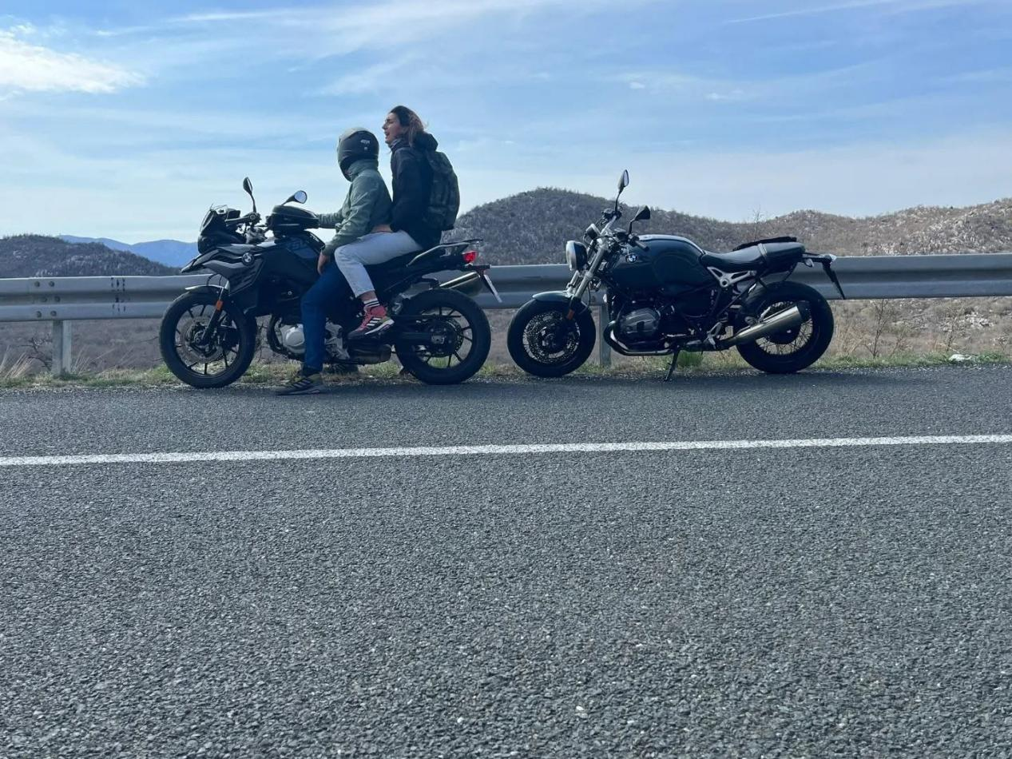

Motorcycle Rental Split: Discover More of Croatia on Two Wheels
Split is an ideal destination for travellers who want to combine history, seaside scenery, local culture, and outdoor exploration. While the city centre is easy to discover on foot, having a motorcycle gives you the freedom to travel beyond the main attractions. With Motorcycle rental Split, visitors can explore nearby beaches, coastal towns, viewpoints, and scenic roads without depending entirely on public transportation.
A motorcycle also gives you the opportunity to turn transportation into part of the adventure. Instead of simply travelling between destinations, you can enjoy the landscapes, make spontaneous stops, and experience the character of Dalmatia at your own pace.

Begin Your Adventure in Split
Before setting off on a longer ride, spend time discovering the city itself. Split has a fascinating historic centre built around the remains of Diocletian's Palace. The surrounding streets combine ancient architecture with modern cafés, restaurants, shops, and lively public spaces.
The Riva waterfront is another popular area for visitors. It is a pleasant place to walk, enjoy a drink, or watch boats moving across the Adriatic.
Once you have explored the central attractions, a motorcycle makes it easier to discover areas outside the busiest tourist streets.

Pick the Motorcycle That Suits You
Choosing the correct motorcycle is an important part of the rental experience. Your selection should depend on your riding experience, planned distance, luggage, and whether you will be travelling alone or with a passenger.
For shorter journeys around Split, a lightweight model may provide plenty of convenience. It can be easier to handle through urban traffic and practical when searching for suitable parking.
If your plans include several hours on the road, consider a motorcycle designed for longer-distance comfort. A suitable seat, riding position, luggage space, and stable handling can make a significant difference during a full-day excursion.
Never choose a motorcycle simply because it has a larger engine. The best option is one that you can operate confidently and safely.

Ride Toward Trogir
Trogir is one of the destinations worth considering when planning a motorcycle trip from Split. The historic town is known for its stone architecture, narrow streets, waterfront setting, and cultural attractions.
The journey can be made part of the experience rather than treated simply as a transfer. Take your time, follow suitable roads, and stop at safe locations when you want to enjoy the scenery.
Once you arrive, park in an appropriate area and explore the historic centre on foot, as many older streets are not suitable for vehicles.

Explore Omiš and the Surrounding Coast
Another popular direction for riders is Omiš. The town sits between the sea and dramatic mountains, creating an impressive setting for a day trip.
Visitors can combine a motorcycle ride with time at the beach, a meal in town, or outdoor activities. The surrounding landscape offers plenty of opportunities for photography and sightseeing.
When planning your return, allow enough time to ride back comfortably. Avoid creating a schedule that forces you to travel quickly or continue riding when you are tired.

Check the Motorcycle Before You Leave
A careful inspection should always be part of the rental process. Before leaving, check the tyres, brakes, lights, mirrors, indicators, fuel level, and visible bodywork.
If you see any scratches, dents, or other existing damage, notify the rental provider and make sure it is documented. Taking photographs before departure can provide additional evidence of the motorcycle's original condition.
You should also understand the rental agreement. Ask about insurance, deposits, fuel requirements, mileage limits, breakdown support, and return arrangements.
Knowing these details in advance makes the rental process much easier.

Plan a Comfortable Day Trip
One of the best things about Motorcycle rental Split is the ability to design your own itinerary. You can decide whether you want a short ride, a coastal day trip, or a longer adventure.
For a relaxed day, choose one or two main destinations rather than attempting to see everything. This gives you enough time to stop for food, take photographs, explore local attractions, and enjoy the road.
Before leaving Split, check your fuel level and navigation route. If you are travelling farther from the city, identify possible fuel stops along the way.

Consider the Weather
Weather can influence the comfort and safety of a motorcycle trip. Summer days in Split can become very warm, particularly during the afternoon.
Start early for longer journeys when temperatures are more comfortable. Carry water and take regular breaks to avoid fatigue.
If rain is expected, reconsider your route or allow additional travel time. Wet roads can reduce grip, while strong coastal winds may make exposed sections more challenging.
Being willing to adjust your plans is an important part of responsible motorcycle travel.

Follow Safe Riding Practices
A motorcycle provides freedom, but that freedom should always come with responsible riding. Follow posted speed limits and local traffic regulations.
Tourist traffic can become heavy during the summer season. Keep a safe distance from other vehicles and watch carefully for pedestrians, cyclists, buses, and cars entering or leaving side roads.
Always wear a properly fitted helmet and suitable protective equipment. Avoid riding after consuming alcohol, and take a break whenever you begin to feel tired.
Safe riding will allow you to enjoy your trip without unnecessary stress.

When to Explore Split by Motorcycle
Spring and early autumn can be particularly pleasant for motorcycle exploration because temperatures are often comfortable and popular tourist areas may be less crowded.
Summer is also an attractive period, especially for travellers who want to combine road trips with beach activities. However, traffic can be heavier during peak holiday months.
Whichever season you choose, checking local weather and road conditions before a long ride is a sensible habit.

Enjoy the Freedom of Two Wheels
Choosing Motorcycle rental Split allows you to experience the city and surrounding Dalmatian region on your own terms. You can explore historic streets, visit coastal towns, discover viewpoints, and enjoy roads surrounded by beautiful Mediterranean scenery.
A successful rental experience starts with selecting the right motorcycle and understanding the rental conditions. Inspect the vehicle carefully, prepare your route, carry essential supplies, and always prioritise safe riding.
With a sensible itinerary and an adventurous spirit, travelling by motorcycle can turn your Split holiday into an exciting journey filled with coastal views, historic discoveries, and unforgettable moments.
Location:- Šibenska ul. 7, 21000, Split, Croatia

