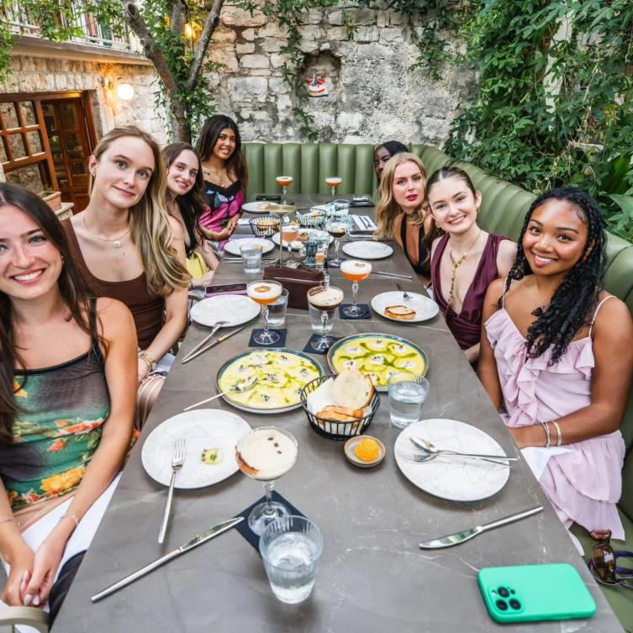

Restaurant Hvar: Discover Authentic Island Dining in Croatia
Hvar is one of the Adriatic's most attractive destinations, offering visitors a combination of historic architecture, scenic coastlines, sunny weather, and a relaxed Mediterranean lifestyle. Alongside its natural beauty, the island has a diverse culinary scene that makes dining an important part of any visit. From fresh seafood and traditional Dalmatian dishes to contemporary Mediterranean cuisine, a Restaurant Hvar experience can introduce travelers to the distinctive flavors of the island.

Why Hvar Is a Great Food Destination
Hvar's cuisine is closely connected to its geography. The Adriatic Sea provides an impressive variety of fish and shellfish, while the island's fertile areas produce vegetables, grapes, olives, herbs, and other seasonal ingredients.
Local cooking generally emphasizes freshness rather than complicated preparation. Grilling, slow cooking, baking, and simple seasoning are common techniques. Olive oil, garlic, herbs, lemon, and fresh vegetables often complement the main ingredients.
For visitors, this approach creates an opportunity to enjoy meals that are both flavorful and closely connected to the local environment.

Fresh Seafood on the Croatian Coast
Seafood is one of the biggest attractions for food lovers visiting Hvar. Local restaurant menus can feature fish, squid, octopus, prawns, mussels, sardines, and other seafood depending on availability.
A simple grilled fish served with vegetables and olive oil can be an excellent introduction to local cuisine. Seafood risotto and pasta are also popular choices, combining fresh ingredients with traditional Mediterranean flavors.
For the best experience, consider dining outdoors. A table overlooking the Adriatic can turn an ordinary meal into a memorable occasion, particularly during the late afternoon or evening.

Traditional Dalmatian Food to Explore
Hvar is part of the Dalmatian region, which has a long and distinctive culinary tradition. Visitors can discover several traditional dishes that reflect local history and ingredients.
Pašticada is a slow-cooked beef specialty often served with gnocchi. Peka is another traditional cooking style in which meat, seafood, or vegetables are slowly cooked beneath a special covered vessel.
Starters can include local cheese, cured meats, olives, bread, and seasonal vegetables. Sharing a selection of appetizers is an easy way to taste several flavors before ordering a main course.
Trying regional specialties at a local Restaurant Hvar allows visitors to experience more than modern tourist cuisine.

Dining Around Hvar Town
Hvar Town provides an extensive selection of restaurants for visitors. Its historic streets and waterfront offer settings ranging from casual cafés to sophisticated dining venues.
A daytime meal can be a convenient break after exploring the town's attractions. In the evening, restaurants become popular places to relax, socialize, and enjoy the coastal atmosphere.
Waterfront restaurants are particularly appealing because of their views. Watching boats in the harbor while enjoying dinner creates a classic island experience.
Since summer is the busiest season, visitors planning to dine at a popular location may want to reserve a table in advance.

Romantic Meals with an Adriatic View
Hvar is an excellent destination for couples, and the island's restaurants provide many romantic settings. Outdoor terraces, stone walls, quiet streets, and sea views create an atmosphere suitable for special occasions.
A couple might enjoy a sunset dinner featuring fresh seafood, regional specialties, and Croatian wine before taking an evening walk through the old town.
When selecting a romantic Restaurant Hvar, look beyond the food. A beautiful setting, attentive service, comfortable seating, and a relaxed atmosphere can make the experience significantly more enjoyable.

Explore the Island's Smaller Communities
Travelers who explore beyond Hvar Town can discover a different side of the island's food culture. Stari Grad, Jelsa, and smaller coastal settlements each offer opportunities to enjoy local cuisine.
Smaller restaurants can sometimes provide a quieter environment and more personal service. Family-owned establishments may use recipes and cooking methods that have been passed down through generations.
Combining sightseeing with food exploration can be a rewarding way to experience the island. A drive through the countryside followed by lunch in a coastal village can provide a welcome break from the busier tourist areas.

Vegetarian and Mediterranean Choices
Hvar's food scene also caters to travelers who prefer vegetarian dishes. Fresh salads, grilled vegetables, pasta, risotto, soups, local cheese, and vegetable-based dishes can be found on many menus.
Mediterranean cuisine naturally provides plenty of fresh ingredients, including tomatoes, peppers, zucchini, eggplant, olives, herbs, and olive oil.
Visitors traveling in groups can also find restaurants offering international dishes, making it easier to accommodate different preferences.

Helpful Tips Before Dining
Choosing a restaurant becomes easier when you decide what matters most to you. Travelers interested in traditional food should look for menus highlighting Dalmatian recipes and seasonal ingredients.
Those who want beautiful scenery can choose a waterfront terrace, while visitors seeking peace and quiet may prefer a location away from the busiest streets.
It is also worth checking menus and recent customer feedback before visiting. If you have allergies or dietary restrictions, ask restaurant staff about ingredients and preparation methods.
During the peak summer season, restaurants can become especially busy during dinner hours, so reservations are often helpful.

Enjoy the Complete Hvar Dining Experience
A visit to Hvar offers countless opportunities to combine good food with beautiful surroundings. The island's culinary identity is built around fresh Adriatic seafood, traditional Dalmatian recipes, Mediterranean ingredients, and modern interpretations of local cuisine.
Whether you choose a casual meal after a day at the beach, a traditional dinner in a historic setting, or a romantic evening overlooking the sea, a Restaurant Hvar experience can become an important part of your holiday.
Take the time to explore local menus, sample traditional specialties, and enjoy the island's relaxed pace. Good food combined with Adriatic scenery and Croatian hospitality can make your Hvar trip truly memorable.
Location:- Dr. Mate Miličića 8, 21450, Hvar, Croatia

